**Hisan Ud Din Banday**

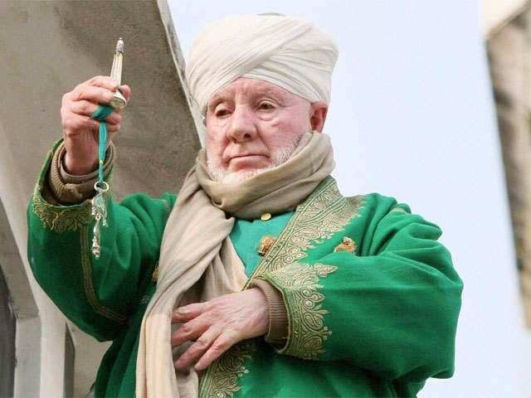

**About:** Ghulam Hassan Banday passed away today after a brief illness. Ghulam Hassan Banday, son of late Nizam-ud-din Banday was one of the custodians of the holy relic of Prophet Muhammad (SAW) at Dargah Hazratbal shrine.Banday displayed holy relic on many important occasions at the Hazratbal shrine. He was also part of the group involved in the recitation of Khatmatul-Mauzamaat, Awraad-e-Sharief on various important occasions that include Eid-e-Milad-un Nabi (SAW) and annual Urs of four rightly-guided Caliphs of Islam.

**Passed Away :** June 23, 2019

**Murdered on:**

**Attack details:**

**Reason to him target**:

**Occupation:** He was a great religious scholar who enlightened the devotees with principles of Islam,” he said.

**Belief:** He was a great religious scholar who enlightened the devotees with principles of Islam .

**URL :** <https://www.greaterkashmir.com/news/srinagar/head-priest-hazratbal-shrine-ghulam-hassan-banday-passes-away/>

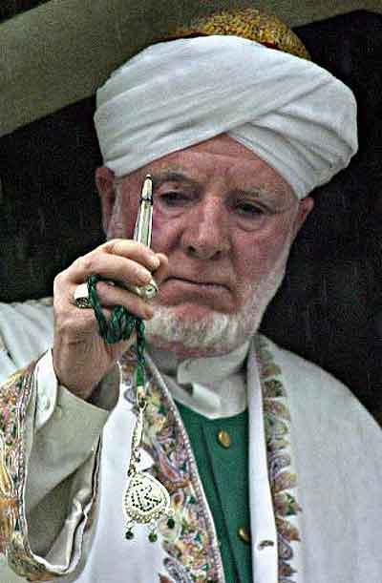 <https://jknewstoday.com/head-priest-hazratbal-shrine-ghulam-hassan-banday-passes-away/>

